Press Release
Household Debt in Israel
Embargo until Wednesday, February 6th, 6:00am
To read the press release on our website >> To read the full study (in Hebrew) >>
Password: taub0119
The rate of household debt in Israel (as a percentage of GDP) is low compared to many developed countries around the world, yet has been on the rise over the past decade. What is the potential danger in this trend and which households are most vulnerable?
A common claim in Israeli socioeconomic discourse is that many households in Israel struggle to cover their daily expenses. A new study by Taub Center Senior Researcher Dr. Labib Shami examines one of the aspects related to households’ economic ability – level of debt – by income decile, age group, and sector. The study’s findings raise concern that the expansion of household debt would particularly affect the financial stability of households belonging to the bottom decile, and that the financial vulnerability of this population is liable to lead to its financial collapse in the case of an economic slowdown.
Competition in the credit industry has increased, and Israelis are taking on more credit
In recent years, several regulatory measures have been taken to promote competition in the banking industry in general, and in the consumer credit market in particular. In 2017, the Knesset passed the Law for Increasing Competition and Reducing Concentration in Israel’s Banking Market, based on the recommendations of the Strum Committee. The changes that took place in the industry – including the entry of non-banking entities into the credit market, the removal of technological barriers, and the integration of new technologies (such as digital banking) – increased the supply of credit and its forms available to households.
Today, there are four main sources of credit available to households: banks, institutional bodies (insurance companies, pension funds and provident funds), credit card companies, and government credit. The breakdown of credit between these sources has changed greatly in recent years: between 2013 and 2017, there was a 148% increase in credit granted to private individuals by credit card companies, and a 140% increase in total loans granted by institutional bodies. At the same time, the growth rate of total credit granted by banks to households declined, especially in 2017 (an increase of 3.9% compared with an increase of 7.4% in each of the five preceding years).
Debt in Israel is low compared to the rest of the world, but is on the rise
According to the Taub Center study, the ratio of household debt to GDP in Israel stands at 42%, while in many other countries the ratio exceeds 100% (as of 2017). However, despite Israel’s relatively good situation, this ratio is on the rise. At the end of 2017, Israel’s household debt balance stood at NIS 530 billion – an increase of 5% since 2016. Between 2008 and 2017, household debt increased by 84%. Total housing debt, usually backed by the value of the asset for which the loan was taken, increased by 70%. In comparison, total non-housing debt increased by 114%.
The expansion of Israeli households’ credit (debt) over the past decade stems from a number of factors: the rise in housing prices, which forces households to take out a higher mortgage; the low interest environment, which encourages taking out loans; and an increase in the supply of credit and private consumption. According to Dr. Shami, “This expansion is fraught with risks that can stem from the over-leveraging of households; that is, sinking deeper into debt relative to their income. This could put their financial stability at risk in the event of an increase in interest rates or a drop in real estate prices.”
About a quarter of households in the bottom decile are in debt
An analysis of household debt level by income decile (according to a long-term household survey from 2016) shows that while the share of those in debt in the bottom decile is relatively low and stands at only 18% (compared to 56% in the top decile), the average ratio between the amount of debt of households in this decile and their annual income is approaching 8. In other words, the total liability of indebted households from the bottom decile is equal, on average, to their total income over 8 years.
According to the Taub Center study, this means that the level of debt of many households in the lowest socioeconomic bracket is unreasonably high given their annual income, and it is doubtful that they will be able to repay this debt. In addition, the highest percentage of households who self-report being in debt (households whose income is insufficient to cover their expenditures and who do not have any savings) is in the bottom decile – about a quarter of the households in this decile, compared with only 3% among households in the top decile.
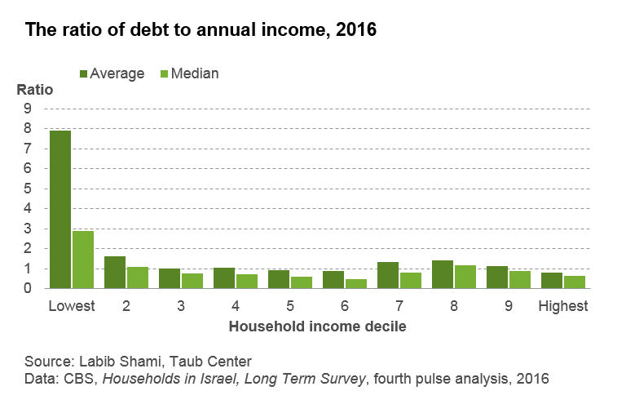
Furthermore, segmenting the population in each decile by age, emphasizes the distress of those in debt from the bottom decile. In this decile, 59% of the indebted population are of prime working age (25-54) and 35% are over the age of 54, compared to a very different ratio among the indebted population in the top decile, where 75% are of prime working age and 22% are 54 and older. The data reveal that households in the top decile primarily take out loans at a younger age and reduce their debt over the years, enabling them to maintain a more uniform level of consumption throughout their lives than households from the bottom decile, and to better weather financial difficulties while minimizing their damage.
Gaps in debt are also evident across different sectors of the population. About a quarter of Arab Israelis in the bottom decile owe money, and their median ratio of debt to annual income is close to 2. Among non-Haredi Jews in this decile the share of those in debt is lower (15%), but the median debt-to-income ratio is higher (close to 3), and among Haredim in the bottom decile, both the share of those in debt and the ratio of debt to annual income are higher (30% are in debt and the median ratio is 13.5).
The Taub Center’s Dr. Shami explains that differences in the indebtedness figures for the Arab Israeli and Jewish populations in general, and for the Haredi population in particular, stem mainly from the type of loan taken out: 64% of indebted non-Haredi Jews and 43% of indebted Haredim from the bottom decile took out a consumer loan, compared with 89% of indebted Arab Israelis from this decile – and, in comparison, 52% of non-Haredi Jews and 72% of Haredim took out a housing loan, compared to only 15% of indebted Arab Israelis in this decile. As pointed out by Dr. Shami, it is possible that the high rate of consumer credit-holders in the Arab Israeli sector stems from difficulties they face in putting up property they own as collateral for a housing loan, such that, in this sector, credit designated as consumer credit is actually being used for housing.
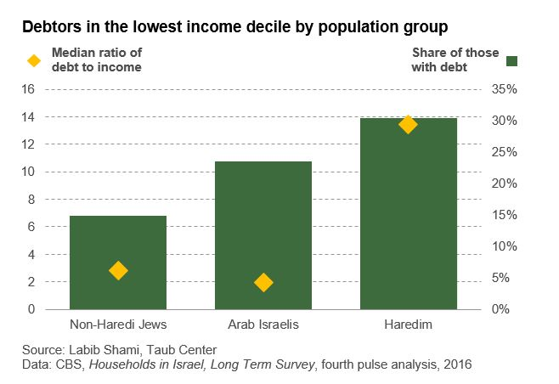
The differences between various income levels are also evident in the source of the loan. To receive non-housing loans, the two bottom deciles rely on non-bank sources at almost twice the rate of the two highest deciles (about 22% compared to about 12%, respectively). In contrast, the rate of applying to banks for non-housing loans is higher at the higher income levels: 88% in the bottom quintile compared to 92% in the top quintile.
“The data reinforce the argument that the entry of non-banking entities into the consumer credit market increases the exposure of households in the bottom deciles to consumer credit,” explains Dr. Shami. “As a result, the risk in this industry has increased both for households, who are more likely to get caught up in debt, and for lenders, who will receive a smaller portion of debt repayments.”

The Taub Center for Social Policy Studies in Israel is an independent, non-partisan socioeconomic research institute. The Center provides decision makers and the public with research and findings on some of the most critical issues facing Israel in the areas of education, health, welfare, labor markets and economic policy in order to impact the decision-making process in Israel and to advance the well-being of all Israelis.
For details, or to arrange an interview, please contact Anat Sella-Koren, Director of Marketing, Communications and Government Relations at the Taub Center for Social Policy Studies in Israel: 050-690-9749.

