Press Release
Expenditure Per Student and Per Class in Primary Education
Embargo until 2.6 (Tuesday) 6:00AM
For the full study
Password: tc0620

The Ministry of Education has two overarching goals that stand in opposition to each other: narrowing educational gaps and encouraging public education. The first goal it realizes through differential budgeting that takes into consideration students’ socioeconomic background factors, while the second it achieves through preferential budgeting of Official (public) education over Recognized but unofficial schools (with private education characteristics). Increased inequality in budgeting along with previously instituted affirmative action measures has meant added support for weaker populations. On the other hand, narrowing the budget gaps between Recognized and Official education, which also expresses affirmative action on behalf of weaker populations, narrows the support for public education.
A new study by Taub Center researchers Nachum Blass and Haim Bleikh looks at the changes in primary education budgeting between 2014 and 2018, and finds that the biggest change has been in Recognized unofficial education (not including Haredi education – Independent and Ma’ayan Hahinuch Hatorani) where there has been an increase of 23% in both the per class and per student budget, while the increase in Official education has been only 7% per class and 11% per student. At the same time, affirmative action per class and per student has grown to varying degrees in all primary school frameworks. In this way, the Ministry of Education reaches its first goal of narrowing gaps between students from different socioeconomic backgrounds, while at the same time, it gets further away from realizing its second goal of strengthening public education.
Most students in Hebrew and Arab education do not benefit from a long school day, while most Druze and Bedouin students do
Official education in Israel includes Hebrew State and State-religious schools, State Arab, Druze, and Bedouin schools. In Hebrew State schools, about 74% of students are in the Official education schools. About 13% of students go to the two Haredi Network schools – Independent and Ma'ayan Hahinuch Hatorani schools. An additional 13% of students are in Recognized (and unofficial) schools, which includes private Hebrew education, State-religious, some Arab education (primarily church schools), Haredi, and Exempt institutions.
The distribution of students in primary education by socioeconomic background shows a number of differences: in Hebrew State education, about 70% of students belong to the two highest socioeconomic quintiles. In Hebrew State-religious schools, about 61% are in this group, while in Official Arab education, there are almost no students who belong to the strong socioeconomic groups. In Hebrew Recognized education (excluding Haredim), the majority of schools serve students from middle to strong populations. Among the Haredi students, those attending the Ma’ayan Hahinuch Hatorani schools are the weakest.
With regard to an extended school day, all Druze students and almost all students from the Bedouin sector benefit from a State-financed extended school day due to their weak socioeconomic status and their geographic location. In all the other educational frameworks, only a small share of students enjoy this benefit: 26% in Arab State schools, 15% in Hebrew State schools, 32% in Hebrew State-religious, and 27% of those in Official Haredi schools. More than 85% of Arab educational institutions have special education classes, versus 63% of Hebrew State and 56% of Hebrew State-religious schools.
The education system encourages Official education based on the school’s Nurture Index, although there is obvious preference for Hebrew-State religious schools over Arab State schools
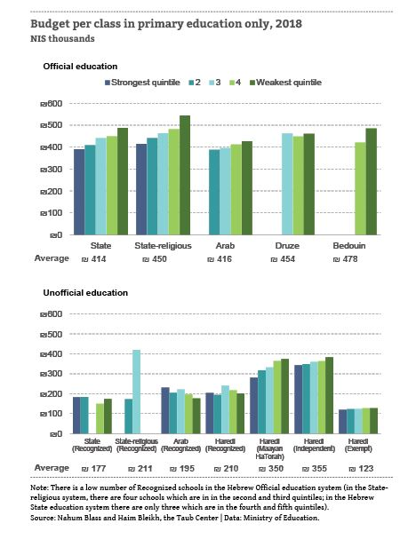
The Taub Center study looks at the overall budget per class allocated by the Ministry of Education (not including local authority budgets and expenditures by parents and private funding), and finds that, in general, the overall budget increases as the socioeconomic level of the institution declines (that is, as the Nurture Index rises).
In a comparison of educational frameworks as a whole, the average expenditure per class and per student in Official education is considerably higher than that in unofficial education; this is an expression of the Ministry’s policy to encourage public Official education. Within Official education, the average expenditure is considerably higher in the Druze and Bedouin sectors, and lowest in the Hebrew State sector. In contrast, in a comparison by socioeconomic background quintiles, it is found that Hebrew State-religious education is budgeted at almost the highest level regardless of quintile, and Arab education at the lowest levels.

Classes have gotten smaller in those schools serving Jewish students from strong socioeconomic backgrounds, and in Arab schools that serve students of all socioeconomic levels
Between 2014 and 2018, the Ministry of Education returned to a differential budgeting practice that had been abandoned in 2008 and also incrementally lowered the maximum number of students per class based on the school’s socioeconomic ranking. At the same time, there were changes in the birth rate in different populations that impacted both the number of students and the budget per student. A look at the demographic changes in those years shows that the share of students in Hebrew State education grew by 1 percentage point, while the share in State-religious and Haredi Network schools grew by one-half a percentage point each; the share in Arab education decreased by two percentage points.
The Taub Center researchers find that, in general, class sizes in primary schools declined by 0.6 students per class, although changes were not uniform throughout the system. The majority of those benefiting from smaller classes are students from stronger socioeconomic backgrounds, where classes were the largest. In Hebrew State and State-religious education, in those schools serving weaker populations, classes actually increased in size, while in Arab education, classes decreased in size over all socioeconomic levels, although the number of Arab schools serving higher socioeconomic populations are almost non-existent.
Budgeting of Recognized schools went up most sharply, and in contrast to the goals of the Ministry of Education to strengthen State education
The Ministry of Education has two overarching goals that often stand in direct conflict with each other – narrowing education gaps and encouraging public education. The first goal is reached through differential budgeting that considers student socioeconomic background. The second is reached by differential budgeting of Official education over Recognized schools. Thus, an increase in unequal budgeting – when there was already affirmative action – means increasing preference for weaker populations. In contrast, decreasing inequality between Official education and Recognized unofficial education, though it is also a form of affirmative action for weaker populations, decreases the advantage to public education. The data indicate a large change between 2014 and 2018 in particular in Recognized education, with an increase of 23% in both the per student and per class budget, while the budget per class in Official education grew by 7% and per student by 11%. The researchers note that this promotes the goal of narrowing socioeconomic gaps at the expense of preference for public education.
The Taub Center research also looks at the impact of changes in budgeting per class and per student over time in three educational frameworks (Official, Recognized, and Haredi Networks), which enables a comparison of changes in inequality in overall budgeting by looking at changes within and between educational frameworks. The analysis shows the following major findings:
- Overall inequality in budgeting declined. The reason for this is a rapid increase in budgeting of Recognized education versus other frameworks – a change that narrows gaps between educational frameworks. In contrast, a look within the frameworks indicates a rise in inequality in budgeting in Official and Recognized education, such that the increase in budgets for students from weaker backgrounds was greater than for stronger students. In Haredi Network schools, the data were less consistent.
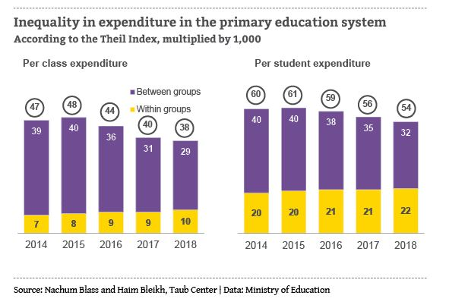
- A look at differential budgeting in Official education broken down into the three frameworks (Hebrew State and State-religious, and State Arab education including Druze and Bedouin) shows that the level of differential budgeting per class rises in each framework, although at different rates in each. This is not the case for inequality per student budgeting where the level of differential budgeting rises in Hebrew and Arab State education, but decreases in Hebrew State-religious schools. “From the perspective of budget per student, the data primarily reflect changes in class size – especially in Hebrew State-religious schools,” explains Haim Bleikh. He adds, “it seems that schools serving students from stronger socioeconomic backgrounds saw decreases in class size, while those schools serving weaker student populations saw increases in class size. As a result, the level of differential budgeting per student in Hebrew State-religious education declined.”
The analysis of changes in per class and per student budget shows that the greatest changes were actually in Recognized education. Educational Policy Program Chair Nachum Blass explains that: “It is possible that changes in the government coalition following the 2015 elections contributed to this, alongside agreements of the Ministry of Education with Recognized unofficial schools.” Inequality between frameworks decreased, although within each system, the inequality grew, lessening the effects of affirmative action.
The President of the Taub Center, Professor Avi Weiss, says “the optimal balance between encouraging the public education system and assisting weaker populations needs to be determined as a matter of policy, and the levels of budgeting set accordingly.”
The Taub Center for Social Policy Studies in Israel is an independent, non-partisan socioeconomic research institute. The Center provides decision makers and the public with research and findings on some of the most critical issues facing Israel in the areas of education, health, welfare, labor markets and economic policy in order to impact the decision-making process in Israel and to advance the well-being of all Israelis.
For details, or to arrange an interview, please contact Anat Sella-Koren, Director of Marketing, Communications and Government Relations at the Taub Center for Social Policy Studies in Israel: 050-690-9749.

