Biographies of Speakers for the Taub Center Conference on
Autism Among Children in Israel: Time for Policy Change?

Opening Remarks
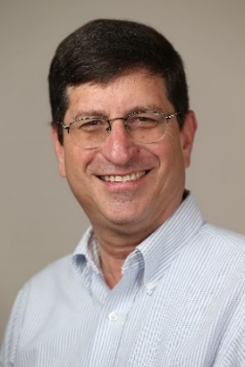
Prof. Avi Weiss
President, Taub Center for Social Policy Studies in Israel; professor of economics, Bar-Ilan University. He holds a PhD in economics from the University of Chicago. Avi has been a senior faculty member at Bar-Ilan University since 1988 and served as chair of the Department of Economics between 2005 and 2008. He specializes in applied economics with a focus on industrial organization, antitrust, labor economics, law and economics, and behavioral and experimental economics.
Avi is the editor of the Israel Economic Association's journal, The Economic Quarterly and is associate editor of Economic Inquiry. In the public work, he has served as Chief Economist and Deputy Director of the Israel Antitrust Authority between 2003 and 2005, was a member of the Anti-Dumping Commission of the Ministry of Industry and Trade between 1999 and 2003, served as a member of the Subcommittee on the Cost of Living and Competition of the Trajtenberg Commission on Social and Economic Change, and acted as a consulting member of the Bachar Intra-Agency Committee for Reform of the Financial Sector. Today, he is the academic representative on the Appeals Committee for the Regulation of Prices of Goods and Services Law and a member of the Competition Task Force of Israel’s Grand Strategy Forum. He has been a research fellow at the Institute of Labor Economics (IZA) in Germany since 2000. Throughout his academic career, he has published more than fifty articles in refereed journals and professional books.

Opening Session: Autism from Local and International Perspectives
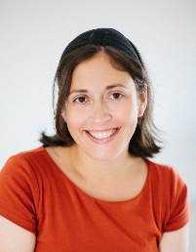
Dr. Sarit Silverman
Senior Researcher, Taub Center. Dr. Silverman holds a PhD and an MA in learning disabilities from the School of Education at the Hebrew University of Jerusalem, and a BA in behavioral sciences from Ben-Gurion University of the Negev. Following her doctoral studies, she joined the Taub Center to apply her background in cognitive and educational development to social policy, exploring areas such as special education, early childhood development, and autism. Her work aims to translate research into policy solutions within health and education services, ensuring that every child in Israel has the support they need to reach their full potential.
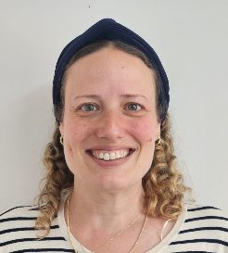
Dr. Michal Illan
Dr. Michal Ilan, Speech-Language Pathologist (SLP), is the VP of Research and Clinical Operations at the Azrieli National Center for Autism and Neurodevelopment Research at Ben-Gurion University. Michal works as a clinical speech-language pathologist in the Early Childhood Psychiatric Unit as part of the autism diagnosis team, and lectures in the Special Education Department at the Hemdat Academic College.
Her research focuses on the early diagnosis of autism, speech and communication development, and the impact of educational settings and therapeutic interventions on the developmental trajectories of autistic children. Alongside her research activities, she is engaged in professional training, clinical supervision, and promoting the connection between research, clinical practice, and public policy. Dr. Ilan holds a PhD in Psychology from Ben-Gurion University of the Negev and an MA in Linguistics from Bar-Ilan University.

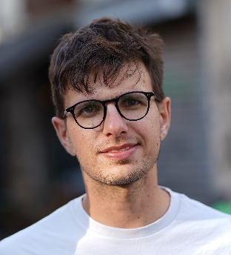
Tamir Gabai
Occupational Therapist B.O.T. Tamir was diagnosed with PDD-NOS in early childhood after difficulties with spoken language development. During his occupational therapy studies, he underwent an evaluation for attention difficulties and received an additional diagnosis of ADHD. Throughout his school years, he attended a mainstream kindergarten with support from a teaching aide and received a range of developmental therapies outside school hours. From first through fifth grade, he studied in a communication classroom while participating in inclusive education in a mainstream classroom for part of the school day. In sixth grade, he transitioned to individual inclusion in a mainstream classroom and remained in inclusive education through the end of high school.
After graduating from high school, he completed Israel's National Service, spending his second year in a communication kindergarten. Until completing his degree, he worked with autistic children and adolescents as a mentor, instructor, and private tutor. Following his involvement in a research project—first as a research assistant and later as a co-researcher—exploring questions of autistic identity, he chose to be open about his autism, including on social media, through a video produced for World Autism Awareness Day in 2022. Since becoming a licensed occupational therapist, he has worked primarily with autistic children and adolescents in a variety of settings, including kindergartens, communication classrooms, a special education school, a private clinic, and home-based therapy.
He also co-taught a course at Ono Academic College. He currently works in geriatric rehabilitation. When he is not working or teaching, he enjoys photography, writing (including opinion pieces, poetry, and children's literature), climbing, and creating across a variety of artistic media.

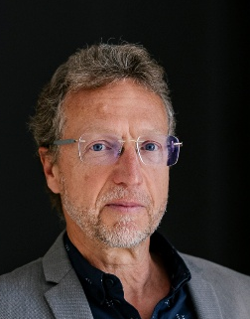
Dr. Christopher Prinz
Senior Policy Analyst and Disability Policy Lead, Directorate of Employment, Labour and Social Affairs, OECD. The OECD is an international organization with 38 members, including Israel, which advises member’s governments in all economic policy matters. Dr Prinz joined the organization 26 years ago and has, since then, led OECD’s work on sickness and disability policy. In this role, he was the main author of several landmark reports – Transforming Disability into Ability (2003); Breaking the Barriers (2010); Sick on the Job? (2012); Fit Mind, Fit Work (2015); Fitter Minds, Fitter Works (2021); Mainstreaming in All Policies and Practices (2022) – and worked individually with policymakers in most member countries. Dr Prinz, who holds a PhD in demography from the University of Vienna, also published on several other policy issues such as labour activation, job displacement, population ageing, and family and work reconciliation.

First Session: Challenges of Needs Assessment and Provision of Health Responses
Chair
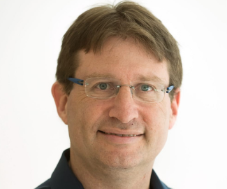
Prof. Nadav Davidovich
Pediatric neurologist, head of the child development and rehabilitation department in the Ministry of Health. Prof. Nadav Davidovitch is an epidemiologist and public health physician who served as the founding director of the School of Public Health at Ben-Gurion University of the Negev, completing his term in 2025. He previously served as Chair of the Department of Health Systems Management and directed the Center for Health Policy Research in the Negev.
Prof. Davidovitch was also Chair of the Association of Public Health Physicians in Israel and served as Israel’s official representative on the Executive Committee of the European Public Health Association. He is currently Chair of the Israeli Health Forum and a member of the Israeli Health Council. He remains actively involved in various national and international health policy committees, including advisory roles for the Israeli Ministry of Health.
Prof. Davidovitch has authored numerous articles and books on public health, health policy, health economics, health systems management, ethics, and the sociology of health. Since the onset of COVID-19, he has contributed to research and policy formulation, advising agencies in Israel and abroad on the need for structural reforms in health systems, with a focus on social issues and addressing health inequalities.

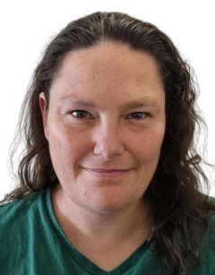
Dr. Naama Yosha Orpaz
Pediatric neurologist, head of the child development and rehabilitation department in the Ministry of Health. She is a specialist in pediatric neurology and child development. She has worked at the Child Development Institute, the pediatric neurology clinic, and the Center for Rare Diseases, which is dedicated to metabolic, genetic, and neurological disorders, and has managed the neuroimmunological diseases clinic. She has been working at the Ministry of Health since 2023 and has since led national policy on child development. This includes initiatives to expand the public workforce within the child development system, reduce gaps in access to developmental services nationwide, promote prevention and early detection of developmental difficulties, advance solutions for children with rare diseases and complex medical needs, and foster inter-ministerial collaborations to establish a unified professional language and reduce bureaucratic burdens for families of children with disabilities.
Dr. Yosha-Orpaz is responsible for the professional leadership of the child development field nationwide, overseeing approximately 160 child development institutes and units and around 180 rehabilitative daycare centers. In 2026, the Department of Autism was transferred from the Mental Health Administration to the Department of Child Development and Rehabilitation at the Ministry of Health, and the field of autism is now also under her management.

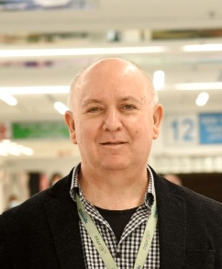
Dr. Gal Meiri
Director, Child and Adolescent Psychiatry Unit, Soroka University Medical Center; Medical Director, The Azrieli National Center for Autism and Neurodevelopment Research, Ben-Gurion University of the Negev. Prof. Gal Meiri is a Child and Adolescent Psychiatrist. He serves as the Medical Director of the Azrieli National Center for Autism and Neurodevelopment and is a faculty member at the Faculty of Health Sciences at Ben-Gurion University of the Negev.
His research focuses on autism and neurodevelopment, with particular interest in early risk factors, developmental trajectories, mental health in autistic children, and the integration of clinical, biological, and population-based data. Prof. Meiri has published extensively in leading international journals and collaborates with research groups in Israel and abroad. Alongside his academic work, he is involved in developing clinical services for children and adolescents and in training professionals in child mental health and autism

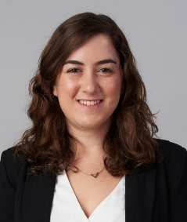
Adv. Rotem Aizik
Advocacy and government relations department manager, ALUT. In her role, Rotem Aizik leads policy promotion and legislative processes in the Knesset and before government ministries across various fields, including health, welfare, and education. Her work involves representing the association in professional forums and Knesset committees, building strategic partnerships and social sector coalitions to advance policy, and advocating for the rights of individuals on the autistic spectrum and their families before government officials and authorities. Previously, she served as an attorney in the legal department of the Ministry of Welfare and Social Affairs and completed her internship in the Civil Department of the State Attorney's Office. Her legal expertise is complemented by practical training in community social work with families of children with disabilities.
She holds a Bachelor's degree in Law and Social Work from the Hebrew University of Jerusalem, and a Master of Business Administration (MBA) in Non-Profit Management from the University of Haifa.

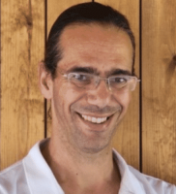
Yair Sadaka, MD, PhD, MHS
Head of MOH INSPIRE Child Development Center of the Negev, Beer Sheva; Myers-JDC-Brookdale Institute CIO; KI Research Institute researcher. Dr. Yair Sadaka is a pediatric neurologist and child development specialist, and Chair of the Israeli Society for Developmental Pediatrics.
His work focuses on autism, child development, and the integration of big data and AI-driven tools for early detection, developmental surveillance, and evidence-based policymaking across healthcare, education, and welfare systems. He leads national and international research initiatives on neurodevelopmental disorders and is a work-package leader in the Horizon Europe R2D2-MH consortium.
Dr. Sadaka has published extensively in leading journals including JAMA Network Open, Pediatrics, and BMJ Mental Health, and is dedicated to bridging clinical research, healthcare innovation, and public policy to improve outcomes for children and families. He also advises national early childhood initiatives and promotes the development of data-driven infrastructure for developmental monitoring and policy planning in Israel.

Second Session: The Education System and Autism – Between Integration and Inclusion
Chair
Dr. Sarit Silverman
Senior Researcher, Taub Center. Dr. Silverman holds a PhD and an MA in learning disabilities from the School of Education at the Hebrew University of Jerusalem, and a BA in behavioral sciences from Ben-Gurion University of the Negev. Following her doctoral studies, she joined the Taub Center to apply her background in cognitive and educational development to social policy, exploring areas including special education, early childhood development, and autism. Her work aims to translate research into policy solutions within health and education services, ensuring that every child in Israel has the support they need to reach their full potential.
.
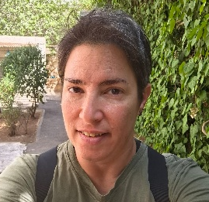
Ayelet Schnur
National Autism Instructor at the Senior Division for Special Education, Ministry of Education. She has extensive experience teaching in autism support classrooms across age groups and mentoring educational and therapeutic professionals who work with autistic students.
In her system-level roles, she leads large-scale initiatives that provide professional guidance and consultation and develop standardized practices to support the inclusion of students on the autism spectrum in the education system. She also designs and leads nationwide professional development programs.
Her work focuses on research and practice related to identity formation, coping with, and processing an autism diagnosis among school-aged students from an affirming perspective. Drawing on this expertise, she leads the development of educational approaches that explore how schools can best support these processes for neurodivergent students in a sensitive and effective manner.

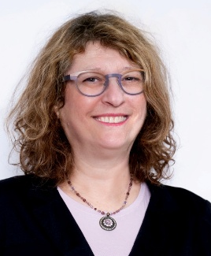
Nechama Faber Ben-Pazi
Clinical Psychologist, Founder and Director of the School-Age Division at 'Oti', the Israeli Association for Autism, Founder and Director of an Autism-Focused Therapy Training Program at 'Oti'. Nechama is a clinical psychologist with over 30 years of experience in autism and the owner of a private practice. She initiated and managed the clinical autism unit within the Educational Psychological Service (Shefach) in Holon. For the past 13 years, she has been the founder and director of the school-age division at "Oti" – The Israeli Autism Association, where she is also a member of the executive forum, the clinical committee, and the research committee. Nechama directs a unique training track in autism-focused psychotherapy. She teaches in the "Primitive Mental States" track within the continuing education program at the School of Psychotherapy, Faculty of Medicine at Tel Aviv University. A renowned lecturer in the field of autism, she has published on "The Multi-Age Child," focusing on the development of autistic children and adolescents. She is the leader in developing the "Spiral Model" – a functional-developmental framework for multidisciplinary work in autism.

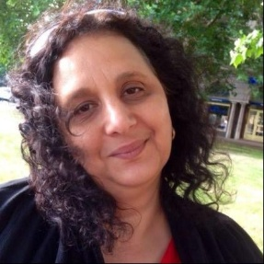
Haya Yaish Azrad
Director, MATIA Ran Regional Support Center. Haya Yeish-Azrad has served as the Director of MATI’A Ran for the past 18 years, leading a broad range of educational and therapeutic services for students with special educational needs in the Shfela region. In her role, she oversees a variety of educational frameworks and support services, including communication kindergartens, communication classes, students integrated into mainstream education, and students eligible for individualized support packages.
Previously, Haya served as the Director of MATIA Petah Tikva and spent four years as a Special Education Supervisor in the Central District. Her professional experience combines extensive knowledge of field-based practice with systemic leadership and policy development in the areas of special education and inclusion.
Throughout her career, Haya has led the development of professional roles and innovative models designed to expand and strengthen the services provided to students with diverse needs and disabilities. Her professional approach is grounded in tailoring support to the specific needs of each student, their family, and the educational team, while creating a continuum of support that enables participation, belonging, and growth for every student.
Alongside her fieldwork, Haya has contributed to leading systemic processes at the national level as the district representative and manager within the Special Education Division. She works to promote innovative approaches, strengthen collaboration among the various stakeholders within the education system, and advance professional frameworks that integrate policy, knowledge, and accumulated field experience.
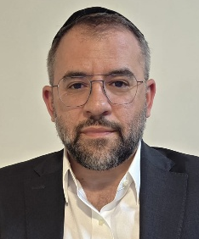
Avi Mimran
Media personality, CEO and founder of the “Mesugalim” nonprofit organization for parents of children on the autism spectrum. Avi Mimran is one of Israel's most prominent media personalities, hosting the flagship nightly news program on "Radio Kol Hai" for over two decades, and serving as a regular panelist on Channel 14's popular show "The Patriots." Alongside his extensive journalism career, Mimran is a leading social advocate dedicated to transforming support systems for special-needs families, a mission driven by his personal experience as a father to a child on the autism spectrum.
In 2016, he founded and currently leads "Mesugalim," a pioneering nonprofit that provides comprehensive support, respite care, weekend retreats, and specialized centers for hundreds of families raising children with autism. Mimran works tirelessly to raise public awareness, combat social stigmas, and establish tailored educational frameworks. As a highly sought-after speaker on special-needs parenting, his lectures bridge media influence with grassroots advocacy, offering an inspiring perspective that combines public action with daily family dedication

